Nana Kwame Baah

POS 604: Quantitative Methods

Dr. Meserve

**GLM introduction: Logit and Probit**

**Question 1a.**

**Table 1.**

Logit and Probit of having rodents’ model with selected independent variables

|  |  |  |  |  |  |  |
| --- | --- | --- | --- | --- | --- | --- |
|  | **Lmodel** | | | **Pmodel** | | |
| *Predictors* | *Log-Odds* | *std. Error* | *CI* | *Log-Odds* | *std. Error* | *CI* |
| (Intercept) | -3.02 *** | 0.07 | -3.15 – -2.89 | -1.79 *** | 0.04 | -1.86 – -1.72 |
| poverty Mean | 5.23 *** | 0.37 | 4.51 – 5.95 | 3.11 *** | 0.22 | 2.68 – 3.53 |
| regext | -0.16 *** | 0.05 | -0.25 – -0.07 | -0.07 *** | 0.03 | -0.12 – -0.02 |
| old | 0.55 *** | 0.05 | 0.45 – 0.65 | 0.31 *** | 0.03 | 0.26 – 0.37 |
| pubhous Mean | -1.94 *** | 0.33 | -2.59 – -1.29 | -1.15 *** | 0.20 | -1.54 – -0.76 |
| hispanic Mean | 1.06 *** | 0.17 | 0.72 – 1.40 | 0.62 *** | 0.10 | 0.42 – 0.82 |
| black Mean | 1.06 *** | 0.09 | 0.88 – 1.24 | 0.61 *** | 0.05 | 0.50 – 0.71 |
| Observations | 12392 | | | 12392 | | |
| R2 Tjur | 0.120 | | | 0.164 | | |
| *\* p<0.1   ** p<0.05   *** p<0.01* | | | | | | |

From the Logit model (Lmodel) in table 1, households whose incomes are below the poverty line, old buildings, percentage of households that are in a Hispanic district, and percentage of households that are in a black district are more likely to have rodent pests. Again, in the Logit model (Lmodel), households with exterminator services, and buildings that are public housing are less likely to have rodent pests in their homes.

For the Probit model (Pmodel) in table 1, households whose incomes are below the poverty line, old buildings, households in Hispanic districts, and households in black districts are more likely to have rodent pests in their homes. While in the same Probit model, households with exterminators, and buildings that are public housing are less likely to have rodent pests in their homes.

**Question 1b.**

Logit and Probit table of having rodents’ model with selected independent variables

|  |  |  |  |  |  |  |
| --- | --- | --- | --- | --- | --- | --- |
|  | **Lmodel** | | | **Pmodel** | | |
| *Predictors* | *Log-Odds* | *std. Error* | *CI* | *Log-Odds* | *std. Error* | *CI* |
| (Intercept) | -3.02 *** | 0.07 | -3.19 – -2.85 | -1.79 *** | 0.04 | -1.89 – -1.70 |
| poverty Mean | 5.23 *** | 0.37 | 4.28 – 6.18 | 3.11 *** | 0.22 | 2.55 – 3.67 |
| regext | -0.16 *** | 0.05 | -0.27 – -0.04 | -0.07 *** | 0.03 | -0.14 – -0.00 |
| old | 0.55 *** | 0.05 | 0.42 – 0.68 | 0.31 *** | 0.03 | 0.24 – 0.39 |
| pubhous Mean | -1.94 *** | 0.33 | -2.80 – -1.08 | -1.15 *** | 0.20 | -1.66 – -0.64 |
| hispanic Mean | 1.06 *** | 0.17 | 0.61 – 1.51 | 0.62 *** | 0.10 | 0.36 – 0.88 |
| black Mean | 1.06 *** | 0.09 | 0.82 – 1.30 | 0.61 *** | 0.05 | 0.47 – 0.75 |
| Observations | 12392 | | | 12392 | | |
| R2 Tjur | 0.120 | | | 0.164 | | |
| *\* p<0.1   ** p<0.05   *** p<0.01* | | | | | | |

From table 2, the percentage of households that are in public housing and households with exterminators are less likely to have rodent pests, thus decreasing the probability of rodents in such homes at a 99 percent confidence level. On the other hand, households whose incomes are below the poverty line, old buildings, households in Hispanic districts, and households in black districts are more likely to have rodent pests in their homes at a 99 percent confidence level. Thus, increasing the probability of having rodent pests.

***I certify that this claim has been reviewed by me, and to the best of my knowledge, believe that it is true and correct***

**Question 1c**

**Graph 1**

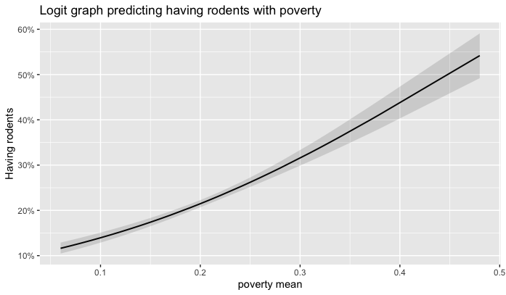

**Graph 2**

From the graphs above, there is no difference. Both graphs are nonlinear graphs with their conditional probabilities ranging from 0 to 0.48 approximately.

**Question 2**

**Table 2**

Logit model of having rodents with an old building and 40 percent poverty in the neighborhood predictor

Predictor estimates

Poverty_ mean (old) 0.488

Black_mean (ex, new) 0.172

Poverty_mean (Hisp) 0.149

Old: Old building, ex: regular exterminator in the building, new: not an old building, Hisp: household in a Hispanic neighborhood.

From table 2, when a building is old, and it is found in a neighborhood where households are below the poverty line, is likely to have rodents. The chance of having rodents is about 50 percent.

Households in a black neighborhood in a building that is not old with regular exterminator service are likely to have rodent pests, but the chances are less. The chance of having rodent pests in such a situation is about 17 percent.

Households in a rich neighborhood in a Hispanic district are likely to have rodents in their homes. The chance of having rodents in such a situation is about 15 percent.

**Question 2b.**

**Table 3.**

Prediction of having rodents for different public housing percentages

Public housing percent estimate

0% (0.00) 0.2687

5% (0.05) 0.2527

10% (0.10) 0.2373

15% (0.15) 0.2225

20% (0.20) 0.2083

25% (0.25) 0.1947

30% (0.30) 0.1817

35% (0.35) 0.1693

38% (0.38) 0.1622

38 percent was included instead of 40 percent because 40 percent was outside the observed data range.

From table 3, there is the probability of having rodents for a 0 to 38 percent range in public housing. Though there is a chance of having rodents in homes, they are less in these situations. The highest chance is about 27 percent. Also, as the percentage of public housing increases, the probability of having rodents in homes reduces. For instance, when buildings are not public housing (0%), the probability of having rodents in homes is around 27 percent and when 38 percent of buildings are public housing, there is about a 16 percent chance of having rodents in the home.

**Question 2c.**

Margin model with change in poverty holding other variables constant

Predictor estimate

Poverty 0.3744

Variables held constant include building not old, regular exterminator service, 9% building in public housing, 17 % black housing neighborhood, and 11% Hispanic neighborhood.

When there is a one percent change in poverty, the marginal increase in the probability of rodents in homes is 0.374 holding all other variables held constant.